[**[NEW] Ultimate AWS Certified Cloud Practitioner CLF-C02 2025**](https://capgemini.udemy.com/course-dashboard-redirect/?course_id=3142166)

*******************************************************************************

**✅ 1. Compute**

* **Amazon EC2 – Virtual servers.**
* **AWS Lambda – Serverless compute.**
* **Amazon ECS / EKS – Container orchestration.**
* **AWS Batch – Batch processing.**
* **AWS Elastic Beanstalk – App deployment.**

**✅ 2. Storage**

* **Amazon S3 – Object storage.**
* **Amazon EBS – Block storage.**
* **Amazon EFS – File storage.**
* **Amazon FSx – Managed file systems.**
* **Amazon S3 Glacier – Archival storage.**
* **AWS Backup – Centralized backup.**

**✅ 3. Database**

* **Amazon RDS – Relational DB.**
* **Amazon Aurora – High-performance relational DB.**
* **Amazon DynamoDB – NoSQL DB.**
* **Amazon DocumentDB – MongoDB-compatible DB.**
* **Amazon ElastiCache – In-memory DB.**
* **Amazon Neptune – Graph DB.**
* **Amazon Timestream – Time-series DB.**
* **Amazon QLDB – Ledger DB.**
* **Amazon Redshift – Data warehouse.**

**✅ 4. Networking & Content Delivery**

* **Amazon VPC – Virtual Private Cloud.**
* **Elastic Load Balancing (ELB) – Load balancing.**
* **Amazon Route 53 – DNS service.**
* **AWS Direct Connect – Dedicated network link.**
* **Amazon CloudFront – CDN.**
* **AWS Global Accelerator – Global traffic routing.**

**✅ 5. Security, Identity & Compliance**

* **AWS IAM – Identity and access management.**
* **AWS KMS – Key management.**
* **AWS Shield – DDoS protection.**
* **AWS WAF – Web application firewall.**
* **AWS Secrets Manager – Secret storage.**
* **AWS Config – Compliance tracking.**

**✅ 6. Management & Monitoring**

* **Amazon CloudWatch – Monitoring and logging.**
* **AWS CloudTrail – API activity tracking.**
* **AWS X-Ray – Distributed tracing.**
* **AWS Systems Manager – Ops automation.**
* **AWS Trusted Advisor – Best practices.**

**✅ 7. Messaging & Email**

* **Amazon SNS – Pub/Sub messaging.**
* **Amazon SQS – Message queues.**
* **Amazon SES – Email sending.**
* **Amazon Pinpoint – Customer engagement.**

**✅ 8. Analytics & Big Data**

* **Amazon Athena – Query data in S3.**
* **AWS Glue – ETL service.**
* **Amazon EMR – Big data processing.**
* **Amazon Kinesis – Real-time streaming.**
* **Amazon QuickSight – BI and visualization.**

**✅ 9. AI/ML**

* **Amazon SageMaker – ML model building.**
* **AWS Rekognition – Image/video analysis.**
* **Amazon Comprehend – NLP.**
* **Amazon Polly – Text-to-speech.**
* **Amazon Lex – Conversational bots.**

**✅ 10. Developer Tools**

* **AWS CodeCommit – Git repositories.**
* **AWS CodeBuild – Build automation.**
* **AWS CodeDeploy – Deployment automation.**
* **AWS CodePipeline – CI/CD pipeline.**

**✅ 11. Migration & Transfer**

* **AWS Database Migration Service (DMS).**
* **AWS Snowball / Snowmobile – Data transfer.**
* **AWS Transfer Family – Managed FTP/SFTP.**

Here’s a comprehensive breakdown of **AWS services related to Databases, Storage, Logging, and Debug/Tracing**:

**✅ Database Services**

* **Amazon RDS** – Managed relational databases (MySQL, PostgreSQL, Oracle, SQL Server, MariaDB).
* **Amazon Aurora** – High-performance MySQL/PostgreSQL-compatible DB.
* **Amazon DynamoDB** – Fully managed NoSQL key-value/document DB.
* **Amazon DocumentDB** – MongoDB-compatible document DB.
* **Amazon ElastiCache** – In-memory caching (Redis, Memcached).
* **Amazon Neptune** – Graph database.
* **Amazon Timestream** – Time-series database.
* **Amazon QLDB** – Immutable ledger database.
* **Amazon Redshift** – Data warehouse for analytics.

**✅ Storage Services**

* **Amazon S3** – Object storage for any type of data.
* **Amazon EBS (Elastic Block Store)** – Block storage for EC2.
* **Amazon EFS (Elastic File System)** – Scalable file storage.
* **Amazon FSx** – Managed file systems (Windows, Lustre, NetApp).
* **AWS Backup** – Centralized backup for AWS resources.
* **Amazon Glacier / S3 Glacier** – Archival storage.

**✅ Logging & Monitoring**

* **Amazon CloudWatch** – Metrics, logs, alarms, dashboards.
* **AWS CloudTrail** – Tracks API calls and user activity.
* **AWS Config** – Resource configuration history and compliance.
* **AWS X-Ray** – Distributed tracing for debugging applications.
* **AWS Audit Manager** – Compliance and audit tracking.

**✅ Debugging & Tracing**

* **AWS X-Ray** – End-to-end tracing for microservices and apps.
* **Amazon CloudWatch Logs Insights** – Query and analyze logs.
* **AWS Lambda Insights** – Debug serverless functions.
* **AWS AppConfig** – Feature flagging and configuration management.

**Transaction Management in AWS Cloud**

**********************************************************************************

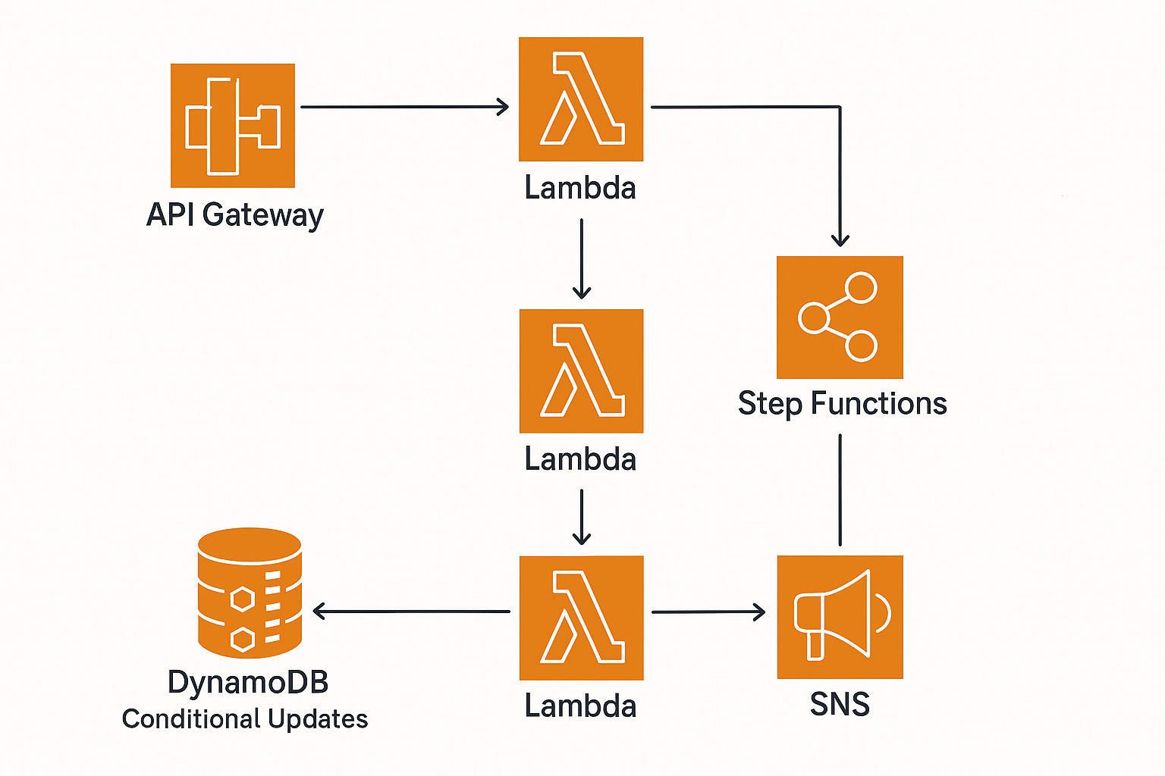

Here’s an **AWS transactional system architecture diagram**:

**Components Explained**

* **API Gateway**: Entry point for client requests.
* **AWS Lambda**: Handles business logic and transaction orchestration.
* **Step Functions**: Manages workflow and rollback for distributed transactions.
* **DynamoDB (Conditional Updates)**: Ensures atomic updates for data consistency.
* **SNS (Simple Notification Service)**: Sends alerts or notifications after transaction completion.

This design supports **ACID-like behavior** using DynamoDB transactions and compensating actions via Step Functions.

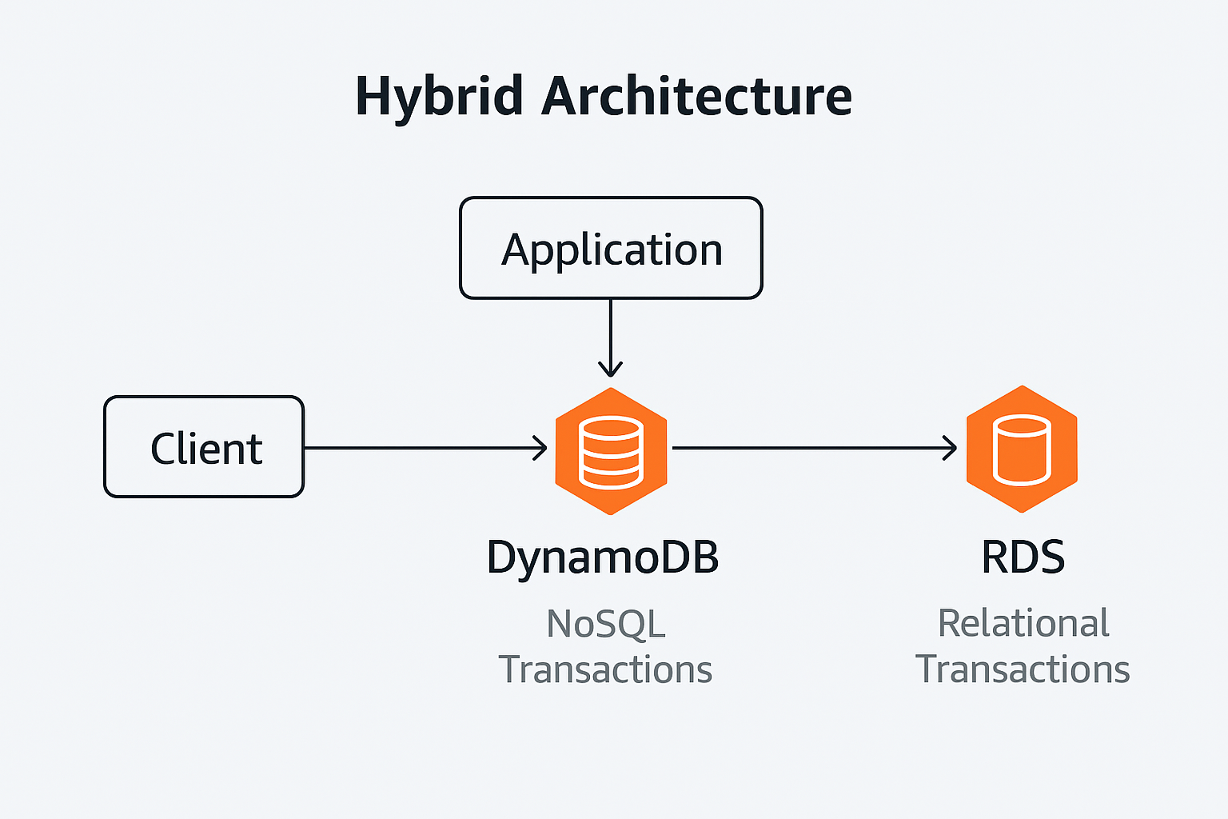

Here’s the **hybrid AWS architecture diagram**:

* **Client → Application → DynamoDB → RDS**
* **DynamoDB** handles **NoSQL transactions** (fast, scalable).
* **RDS** handles **relational transactions** (ACID-compliant).
* The application layer orchestrates writes/reads between both databases.

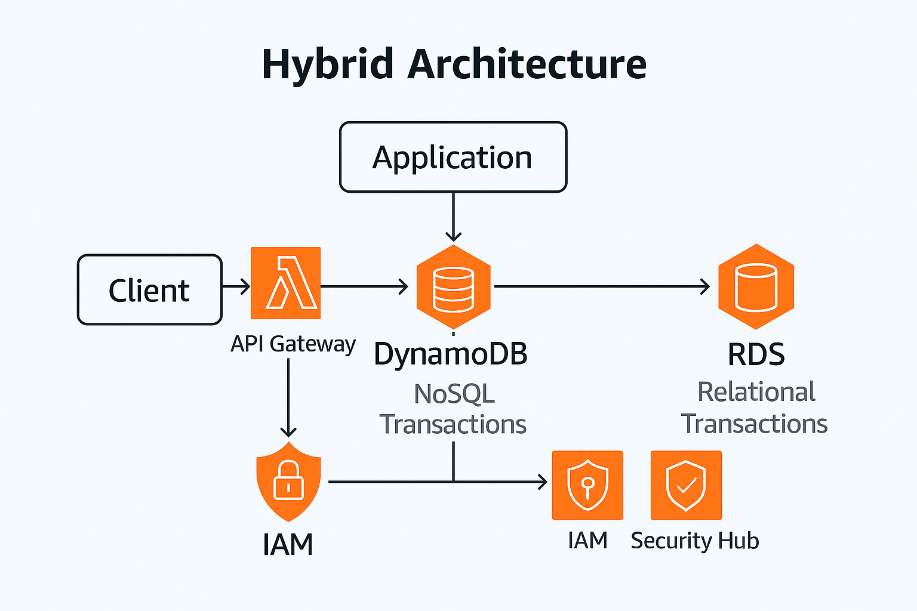Here’s the **production-ready hybrid AWS architecture**:

**Components Added**

* **API Gateway**: Handles secure API requests from clients.
* **AWS Lambda**: Executes business logic and orchestrates between DynamoDB and RDS.
* **IAM**: Provides fine-grained access control for Lambda, API Gateway, and databases.
* **Security Hub**: Centralized security and compliance monitoring.

**Flow**

1. **Client → API Gateway → Lambda**
2. Lambda:
   * Writes transactional data to **RDS** (ACID).
   * Writes non-transactional data to **DynamoDB**.
3. **IAM policies** secure all interactions.
4. **Security Hub** monitors compliance and threats.

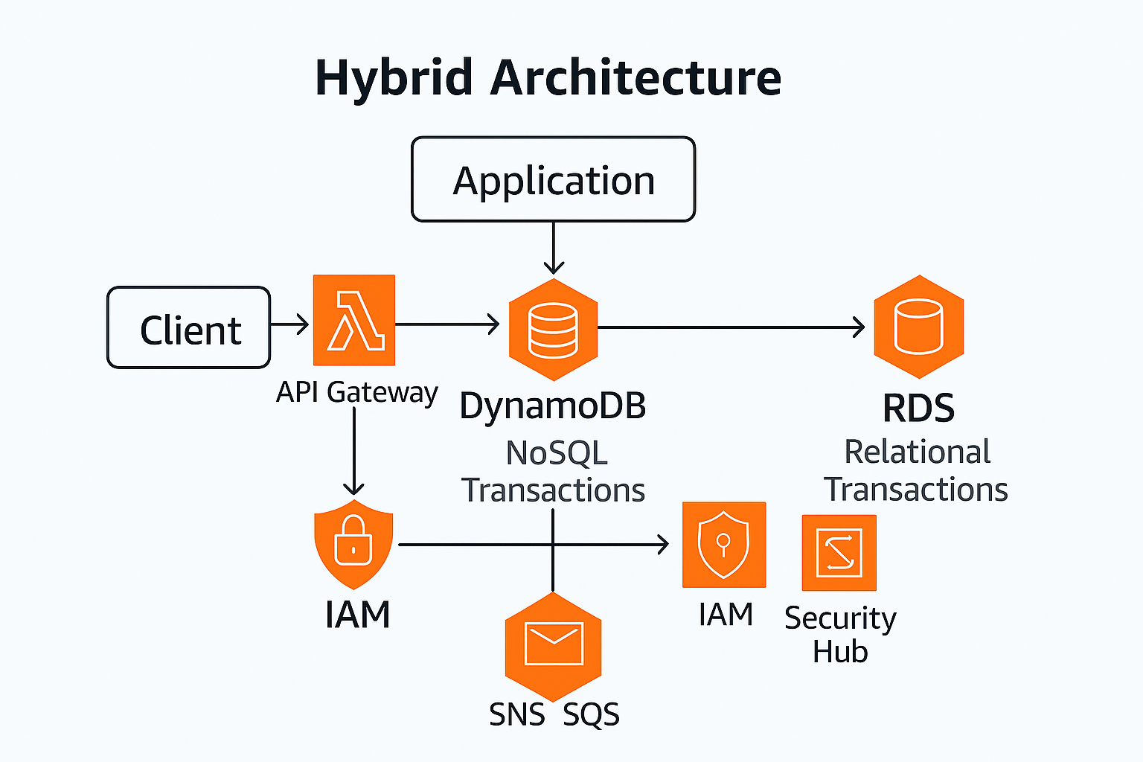Here’s the **enhanced production-ready hybrid AWS architecture**:

**New Components Added**

* **Amazon ElastiCache** (not shown in the diagram but will be placed between Application and DynamoDB/RDS for caching frequently accessed data).
* **Amazon SNS/SQS**:
  + SNS for **event notifications**.
  + SQS for **asynchronous message queues** to decouple services and improve scalability.
* **IAM**: Secures all interactions.
* **Security Hub**: Monitors compliance and threats.

**Final Flow**

1. **Client → API Gateway → Lambda**
2. Lambda:
   * Writes transactional data to **RDS**.
   * Writes non-transactional data to **DynamoDB**.
   * Publishes events to **SNS**, which can trigger other services.
   * Sends messages to **SQS** for asynchronous processing.
3. **ElastiCache** speeds up reads for both RDS and DynamoDB.
4. **IAM** and **Security Hub** enforce security and compliance.

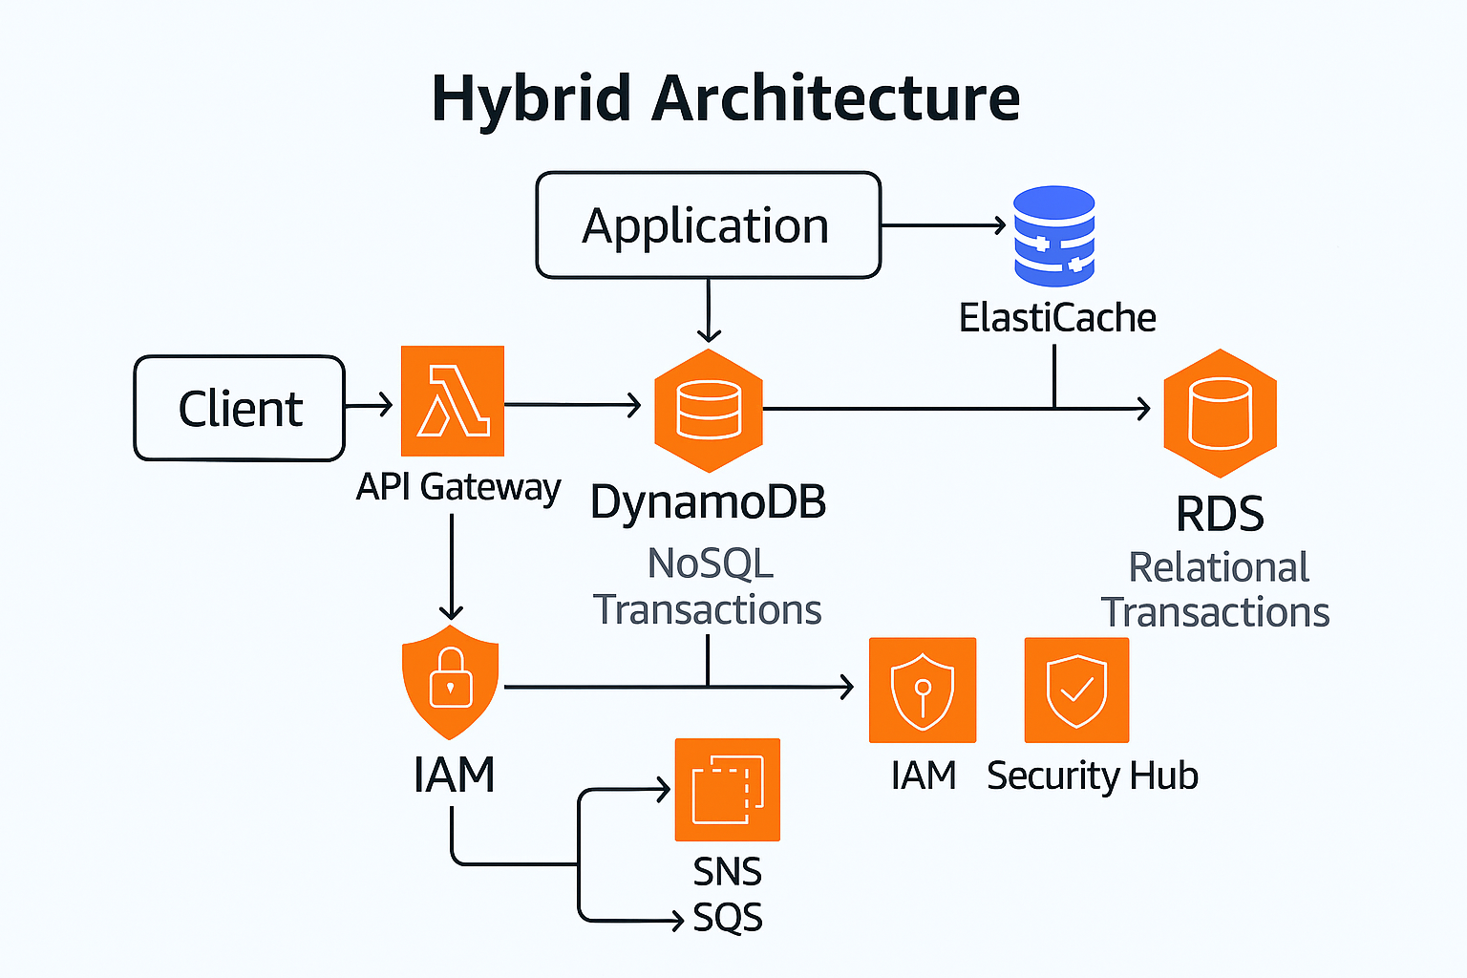

Here’s the **detailed production-ready hybrid AWS architecture**:

**Added Components**

* **Amazon ElastiCache**:
  + Positioned between the application and RDS for caching frequently accessed relational data.
  + Improves performance and reduces database load.
* **Event-Driven Flow (SNS + SQS)**:
  + **SNS** publishes events (e.g., order placed).
  + **SQS** queues messages for asynchronous processing (e.g., inventory updates, notifications).
* **Security Layer**:
  + **IAM** for fine-grained access control.
  + **Security Hub** for compliance and threat monitoring.

**Flow**

1. **Client → API Gateway → Lambda**
2. Lambda:
   * Writes transactional data to **RDS** (ACID).
   * Writes non-transactional data to **DynamoDB**.
   * Publishes events to **SNS**, which fans out to **SQS** for async tasks.
3. **Application** uses **ElastiCache** for fast reads from RDS.
4. **IAM** secures all interactions; **Security Hub** monitors compliance.

***********************************************************************

create a step-by-step deployment guide for this architecture using AWS services?

**Copilot said:**

**Copilot**

Here’s a **step-by-step deployment guide** for the hybrid AWS architecture with **RDS, DynamoDB, ElastiCache, Lambda, API Gateway, SNS/SQS, IAM, and Security Hub**:

**✅ Step 1: Set Up Networking**

* Create a **VPC** with:
  + Public and private subnets.
  + Internet Gateway for public access.
  + NAT Gateway for private subnet outbound traffic.
* Configure **Security Groups** for Lambda, RDS, and ElastiCache.

**✅ Step 2: Deploy Amazon RDS**

* Choose **RDS (MySQL/PostgreSQL)** for relational transactions.
* Enable:
  + **Multi-AZ deployment** for high availability.
  + **Encryption at rest** using AWS KMS.
* Configure **parameter groups** for performance tuning.

**✅ Step 3: Deploy Amazon DynamoDB**

* Create DynamoDB tables for NoSQL data.
* Enable:
  + **On-demand or provisioned capacity**.
  + **DynamoDB Streams** for event-driven triggers.
* Use **TransactWriteItems** for atomic operations.

**✅ Step 4: Add Amazon ElastiCache**

* Deploy **Redis or Memcached** cluster in private subnet.
* Configure:
  + **Replication groups** for high availability.
  + **IAM roles** for secure access.
* Integrate with application for caching RDS queries.

**✅ Step 5: Configure API Gateway**

* Create **REST API** or **HTTP API**.
* Enable:
  + **Authorization** using IAM or Cognito.
  + **Rate limiting** and **throttling**.
* Integrate with **Lambda functions**.

**✅ Step 6: Deploy AWS Lambda**

* Create Lambda functions for:
  + Orchestrating writes to RDS and DynamoDB.
  + Publishing events to SNS.
* Configure:
  + **Environment variables** for DB credentials (use **Secrets Manager**).
  + **VPC access** for private resources.

**✅ Step 7: Set Up Event-Driven Flow**

* Create **SNS topics** for publishing events.
* Create **SQS queues** for asynchronous processing.
* Subscribe Lambda or other consumers to SNS/SQS.

**✅ Step 8: Security & Compliance**

* Configure **IAM roles and policies**:
  + Lambda → DynamoDB, RDS, SNS, SQS.
  + API Gateway → Lambda.
* Enable **AWS Security Hub** for compliance checks.
* Turn on **CloudTrail** and **CloudWatch** for monitoring.

**✅ Step 9: Monitoring & Scaling**

* Enable **Auto Scaling** for DynamoDB and Lambda concurrency.
* Use **CloudWatch dashboards** for metrics.
* Configure **alarms** for latency, errors, and queue depth.

**✅ Step 10: Test & Optimize**

* Test API endpoints via **Postman** or **curl**.
* Validate caching with ElastiCache.
* Simulate load and tune RDS/DynamoDB capacity.

Generate a Terraform script to provision this entire architecture automatically?

**Copilot said:**

**Copilot**

Analysis

Here’s your **Terraform script** that provisions the hybrid AWS architecture:

✅ **Includes**:

* VPC, subnets, security groups
* **Amazon RDS** (MySQL)
* **DynamoDB** table
* **ElastiCache** (Redis)
* **API Gateway**
* **Lambda function** with IAM role
* **SNS topic** and **SQS queue**
* **AWS Security Hub** for compliance

📂 Download the file here:

[aws_hybrid_architecture.tf](blob:https://m365.cloud.microsoft/9b4a6fe7-b6a1-4644-a832-57d3f5198251)

extend this Terraform script with auto-scaling for Lambda and DynamoDB,

**Copilot said:**

**Copilot**

Analysis

Here’s the **extended Terraform script** with **auto-scaling for Lambda and DynamoDB**:

✅ **Added Features**:

* **Lambda Auto Scaling**:
  + Provisioned concurrency scaling using **Application Auto Scaling**.
* **DynamoDB Auto Scaling**:
  + Target tracking policies for **read and write capacity units**.

📂 Download the file here:

[aws_hybrid_autoscaling.tf](blob:https://m365.cloud.microsoft/91341401-bec7-4cb9-a0b8-d83d832a2a52)

**Next Steps**

1. Merge this file with your base architecture script or apply separately.
2. Run:

**Shell**

terraform init

terraform plan

terraform apply

1. Adjust **min/max capacity** and **target utilization** as per workload.

**Next Steps**

1. Install **Terraform** and configure AWS credentials:

**Shell**

terraform init

terraform plan

terraform apply

1. Upload your Lambda code as lambda.zip before applying.
2. Adjust region, instance sizes, and security settings as per your requirements.

**********************************************************************************

**Exception Management**

**********************************************************************************

How we do exception management in AWS cloud?

**Copilot said:**

**Copilot**

Exception management in AWS cloud refers to how you **detect, handle, and respond to errors or failures** in applications and services running on AWS. Since cloud environments are distributed and dynamic, exceptions can occur due to network issues, resource limits, service outages, or application bugs. Effective exception management ensures **resilience, fault tolerance, and minimal downtime**.

**✅ Key Strategies for Exception Management in AWS**

**1. Application-Level Exception Handling**

* Implement **try-catch blocks** in your code for predictable errors.
* Use **idempotent operations** so retries don’t cause duplicate effects.
* Apply **circuit breaker patterns** to prevent cascading failures.

**2. AWS Native Services for Exception Handling**

* **AWS Lambda**:
  + Configure **DLQ (Dead Letter Queue)** using **SQS or SNS** for failed invocations.
  + Use **Lambda Destinations** for success/failure routing.
* **Amazon SQS & SNS**:
  + Use **DLQs** for messages that fail processing after retries.
* **Step Functions**:
  + Built-in **error handling and retries** with Catch and Retry blocks.
* **API Gateway**:
  + Define **custom error responses** and **mapping templates** for exceptions.

**3. Monitoring & Alerting**

* Enable **Amazon CloudWatch**:
  + Create **alarms** for error metrics (e.g., Lambda errors, API Gateway 5xx).
  + Use **CloudWatch Logs Insights** for debugging.
* Enable **AWS X-Ray** for tracing exceptions across microservices.

**4. Automated Remediation**

* Use **AWS Systems Manager Automation** to run scripts when exceptions occur.
* Trigger **SNS notifications** for critical errors and integrate with **Ops tools** like PagerDuty.

**5. Best Practices**

* **Centralize logging** using **CloudWatch Logs** or **ELK stack**.
* Implement **structured error codes** for easier troubleshooting.
* Use **retry policies with exponential backoff** for transient errors.
* Apply **graceful degradation** (e.g., serve cached data if DB fails).